|  |  |  |
| --- | --- | --- |
| NAME | : | M. JAMALUDIN NUR |
| NIM | : | A11.2022.14616 |
| MATKUL | : | DATA MINING |

TUGAS 7 Data Mining Decision Tree

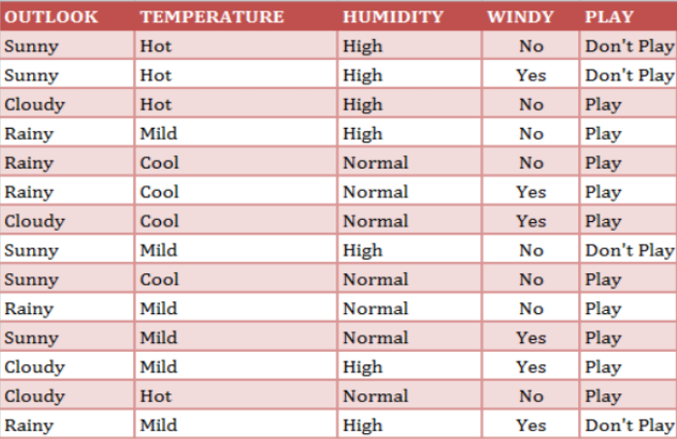

**Mengitung Entropy**

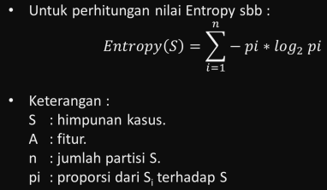

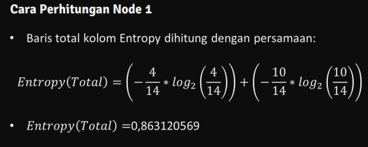

Mengitung Nilai Gain

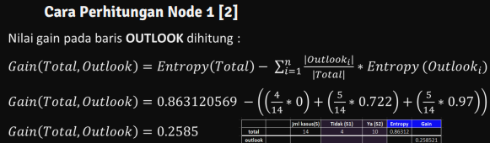

Hasil Perhitungan Node

|  |  |  |  |  |  |  |
| --- | --- | --- | --- | --- | --- | --- |
|  |  | jml Kasus(S) | Don’t Play(S1) | Play(S2) | Entropy | Gain |
| total |  | 14 | 4 | 10 | 0.86312 |  |
| outlook |  |  |  |  |  | 0.258521 |
|  | Cloudy | 4 | 0 | 4 | 0 |  |
|  | Rainy | 5 | 1 | 4 | 0.72193 |  |
|  | Sunny | 5 | 3 | 2 | 0.97095 |  |
| Temp |  |  |  |  |  | 0.1838509 |
|  | Cool | 4 | 0 | 4 | 0 |  |
|  | Hot | 4 | 2 | 2 | 1 |  |
|  | Mild | 6 | 2 | 4 | 0.9183 |  |
| Humidity |  |  |  |  |  | 0.3705065 |
|  | High | 7 | 4 | 3 | 0.98523 |  |
|  | Normal | 7 | 0 | 7 | 0 |  |
| windy |  |  |  |  |  | 0.0059777 |
|  | No | 8 | 2 | 6 | 0.81128 |  |
|  | Yes | 6 | 4 | 2 | 0.9183 |  |

Kasus Jika Humidity High and Outlook Rainy

|  |  |  |  |  |  |  |
| --- | --- | --- | --- | --- | --- | --- |
|  |  | jml Kasus(S) | Don’t Play(S1) | Play(S2) | Entropy | Gain |
| Humidity High and Outlook Rainy |  | 2 | 1 | 1 | 1 |  |
| Temp |  |  |  |  |  | 0 |
|  | Cool | 0 | 0 | 0 | 0 |  |
|  | Hot | 0 | 0 | 0 | 0 |  |
|  | Mild | 2 | 1 | 1 | 1 |  |
| Windy |  |  |  |  |  | 1 |
|  | No | 1 | 0 | 1 | 0 |  |
|  | Yes | 1 | 1 | 0 | 0 |  |

